**Anne Hathaway: A Simple Biography**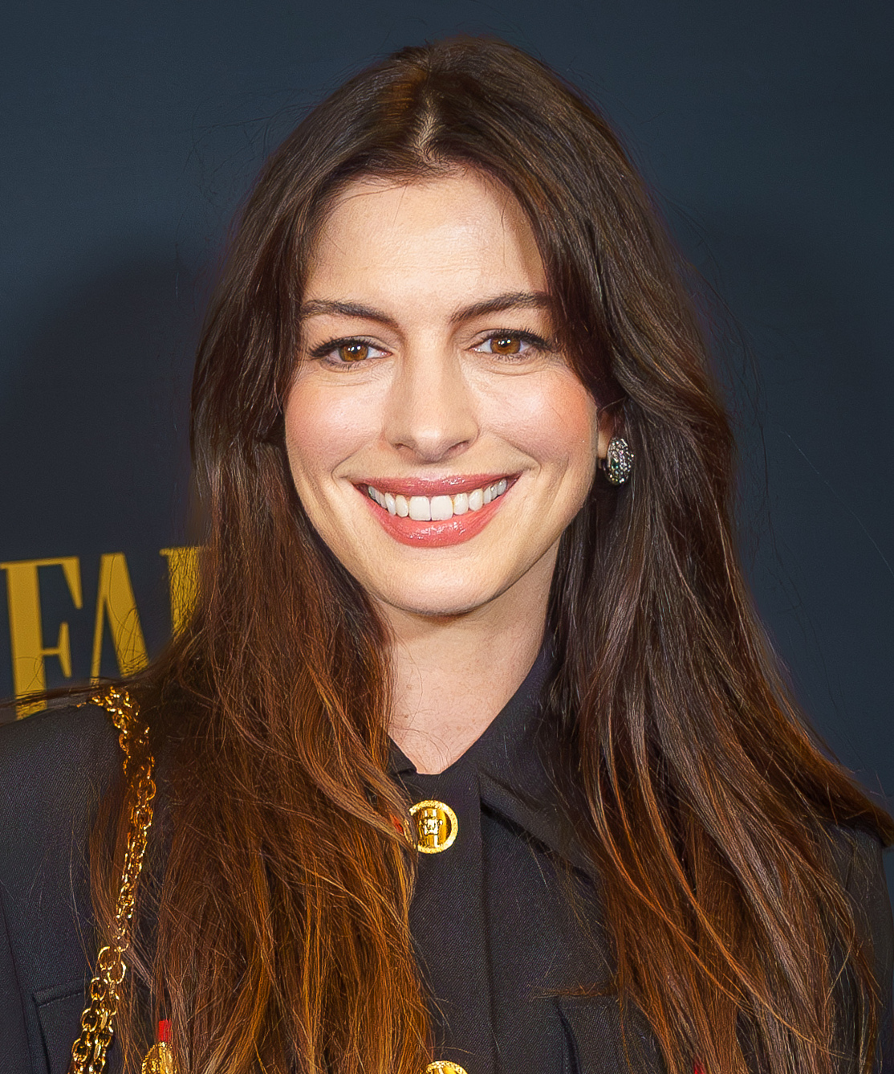

Anne Hathaway is a famous American actress. She was born on **November 12, 1982**, in **Brooklyn, New York**. Her full name is **Anne Jacqueline Hathaway**. When she was six years old, her family moved to **Millburn, New Jersey**.

Anne's father, **Gerald Hathaway**, is a lawyer, and her mother, **Kate McCauley Hathaway**, is a former actress. Anne has two brothers: one older and one younger. As a child, Anne loved watching her mother perform in plays. This inspired her to become an actress.

In high school, Anne acted in many school plays. She also sang in the school choir. She was a good student and enjoyed performing. After high school, she studied at **Vassar College** and later at **New York University**.

Anne's first big role was in a TV show called **"Get Real"** in 1999. She played a teenager named Meghan Green. The show lasted one season, but it helped Anne start her acting career.

In 2001, Anne became very famous for her role in **"The Princess Diaries"**. She played **Mia Thermopolis**, a teenager who discovers she is a princess. The movie was a big success, and Anne became a star. In 2004, she acted in the sequel, **"The Princess Diaries 2: Royal Engagement"**, and in **"Ella Enchanted"**, where she played a girl under a magic spell.

Anne wanted to show she could act in serious movies too. In 2005, she acted in **"Brokeback Mountain"**, a drama about two cowboys. In 2006, she starred in **"The Devil Wears Prada"**, playing a young woman working for a fashion magazine editor. This movie was very popular.

In 2008, Anne acted in **"Rachel Getting Married"**, playing a woman with personal problems. Her performance was praised, and she received her first **Academy Award** nomination.

In 2010, Anne played the **White Queen** in **"Alice in Wonderland"**. She also acted in **"Love and Other Drugs"**, a romantic drama. In 2011, she voiced a character in the animated movie **"Rio"**.

In 2012, Anne played **Catwoman** in **"The Dark Knight Rises"**, a superhero movie. That same year, she acted in the musical **"Les Misérables"**, playing **Fantine**, a poor woman. Anne sang in the movie and won an **Academy Award for Best Supporting Actress**.

Anne continued to act in various movies. In 2014, she was in **"Interstellar"**, a science fiction film. In 2015, she starred in **"The Intern"**, a comedy about a young businesswoman and her older intern. In 2018, she acted in **"Ocean's 8"**, a heist movie with an all-female cast.

Anne also appeared in **"The Hustle"** (2019), a comedy about two con artists, and in **"The Witches"** (2020), a fantasy film based on a book by Roald Dahl. In 2022, she starred in the TV series **"WeCrashed"**, about the rise and fall of a company called WeWork.

In her personal life, Anne married **Adam Shulman**, an actor and jewelry designer, in 2012. They have two sons: **Jonathan** and **Jack**. Anne is known for her charity work. She supports children's hospitals and fights for women's rights. In 2016, she became a **UN Women Goodwill Ambassador**, promoting gender equality.

Anne Hathaway is admired for her talent, versatility, and kindness. She continues to act in movies and supports important causes around the world.